**Ideation Phase**

**Brainstorm & Idea Prioritization Template**

|  |  |
| --- | --- |
| Date | 31 October 2025 |
| Team ID | NM2025TMID08347 |
| Project Name | Laptop Request Catalog Item |
| Maximum Marks | 4 Marks |

**Brainstorm & Idea Prioritization Template:**

This guided project demonstrates how to create a **Service Catalog Item** in **ServiceNow** that allows employees to request laptops efficiently and accurately. The goal of this project is to streamline the laptop request process, reduce manual paperwork, and ensure all necessary approvals and configurations are handled automatically.

The project begins with the creation of a **Service Catalog Item** named **“Laptop Request”** under the IT Services category. The form includes key fields such as **Laptop Type, Purpose, Department, Justification, Expected Date, and Manager Approval**.  
Dynamic form behavior is implemented using **Catalog Client Scripts and UI Policies** to display or hide fields based on user selection. For example, if a user selects “High-Performance Laptop,” additional justification fields appear automatically.

A **workflow** is designed to handle approvals — when a user submits a request, it is routed to their manager for approval and then to the IT fulfillment team for processing. Once approved, a task is generated for IT staff to assign and deliver the requested laptop.

This ensures requests are processed quickly, reduces errors, and provides a centralized tracking mechanism through ServiceNow. The result is a smoother, more transparent, and automated laptop issuance process.

**Step-1: Team Gathering, Collaboration and Select the Problem Statement**

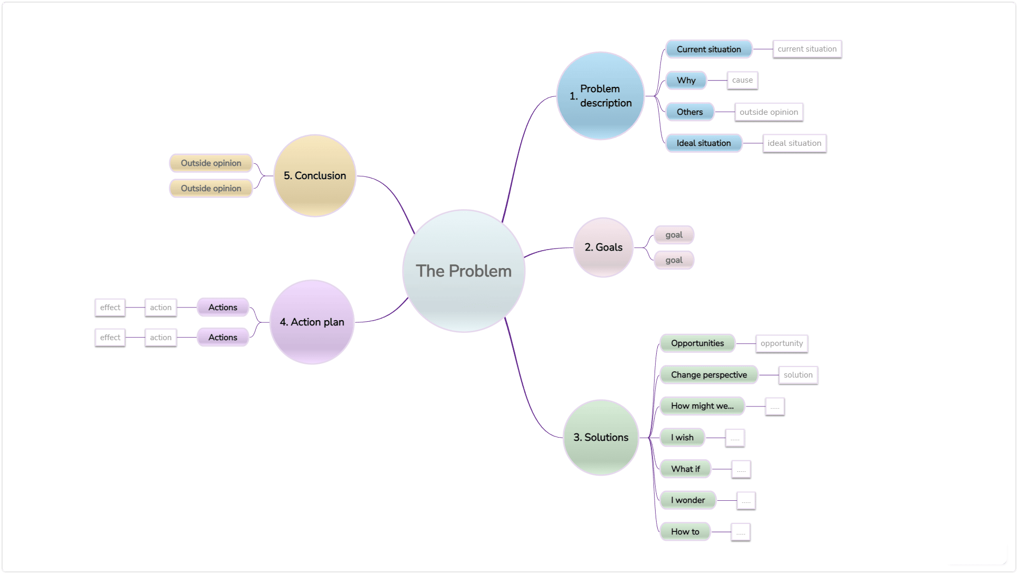

**Step-2: Brainstorm, Idea Listing and Grouping**

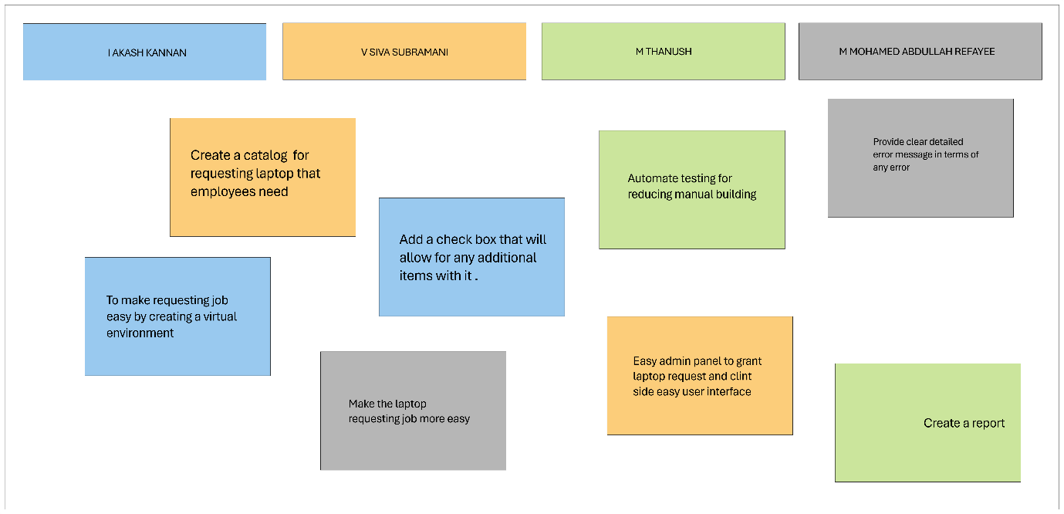

**Step-3: Idea Prioritization**

Idea prioritization was done to focus on the most impactful and feasible features first. The team prioritized **automation and user-friendliness** since these had the greatest benefit for both employees and IT staff.

* **Priority 1:** Automate approval workflow
* **Priority 2:** Dynamic field visibility
* **Priority 3:** Asset assignment and tracking integration

This prioritization helps simplify implementation and ensures the system addresses critical needs like efficiency and transparency.

By breaking down tasks into clear components — form creation, approval logic, and task automation — the project achieved clarity and structure. The visual workflow and well-defined form elements improved communication between development and testing teams.

Overall, **the idea prioritization process ensured the successful execution of the ServiceNow Laptop Request Catalog Item**, making it a scalable and maintainable solution for IT service automation.